St John the Evangelist
London Road, Bourne End

Reports for the APCM
Sunday 30th April 2023

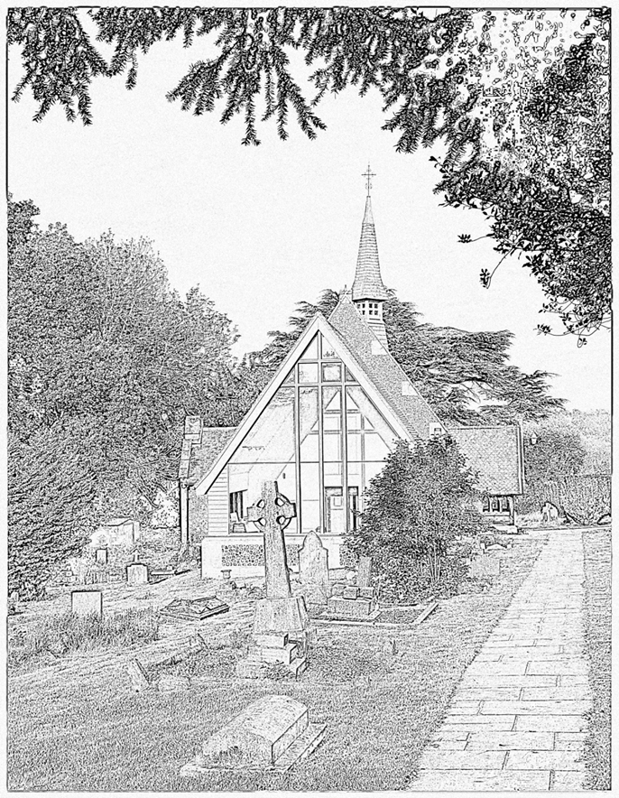

Minutes of the Annual Meeting on Sunday 15th May 2022
Over the past year, the PCC have met in January, March on zoom and then in person in May, July, September and November 2021.

There are seven elected members of the PCC. These are: Laura Frey, Edith Harkins, Sue Marshall, Mike Pritchard, Barbara Driver and Karen Evans. Helen King and John Marshall are on the committee as Churchwardens and Edith Harkins as Treasurer.

We were sorry to lose George Einchcombe from the PCC who resigned after moving out of the area. We thank him for his time on the PCC and wish him all the best.

Our APCM which was due to be held on 25th April 2021 and our Gift Day was held at our Harvest service in October. The money from the gift day has now been allocated so that a proportion will be going into church funds and each of the following charities will receive a donation: MAF £1000, Salvation Army £460. Liberty Tea Rooms £460 and Sunnyside Rural Trust £460.

The following appointments were made further to the APCM last year:
Treasurer – Edith Harkins,
Electoral Roll Officer – Susan Marshall
Chairman – Rebecca Fardell
Church Wardens – John Marshall and Helen King
Deputy Wardens – Sue Marshall and Michael Pritchard
Safeguarding Office – Karen Evans

The main topics for discussion throughout the year have been:
- Continued strategies for maintaining Covid safe worship.
- Following up the recommendations of the Quinquennial Inspection.
- Continuing with the plans and application to the DAC for moving the reredos and communion table and restoring the original communion table that had been found underneath the current carved table. Also for obtaining permission to use this smaller table, positioned in the chance, for communion services in the interim period.
- Further developing links with the village community through events organised by the Village Association.
- Making contact with the new residents of the houses in The Paddocks at the top of Bourne End Lane.
- Giving and allocation of funds raised on the gift day, and further giving throughout the year.
- Updates on safeguarding training from the Diocese.
- Regular reviewing of our Mission Action Plan.
- The ongoing problems with Glis glis and the need to eradicate them from the building.
- Arranging continuing maintenance of the church and churchyard.

Sadly, some of our regular events have had to be cancelled this year. This included coffee mornings, Pot Luck lunches, and the Easter Day, Remembrance Day and Carol services. However, we are grateful that we have been able to open the church again for public and private prayer in recent months.
Members of the PCC and others were thanked for the hard work and time that they put into making the church a safe and welcoming place of worship and for their support in keeping the church building in good order even during these periods of restrictions and lockdown.
Helen King (Churchwarden)

Vicar’s Report

2022 was another year where Covid 19 continued to have an impact. Many people and activities took longer to return to meeting in person than we might have expected. However, it was a joy to be able to come together more freely and more often, and to lift some of the restrictions that the pandemic had imposed.

The rest of this report gives an overview of what happened in St John’s during 2022, none of which would have been possible without you all giving so generously of your gifts, time, and money. I would like to thank you for your commitment to St John’s and for your care and support of me. I am thankful for each and everyone of you and continue to be deeply grateful to God that I have the privilege and joy of being your vicar. In particular, I wish to thank our churchwardens, Helen and John, who bring much thought and prayer to this vital role and all that Rachel contributed to our life at St John’s as our curate. I also would like to give special thanks to our team of preachers and leaders who take services at St John’s as well as our PCC who all give generously of their time and wisdom. We are all blessed by their contributions to our church life.

Our vision is to ‘grow in Spirit and in number so that St John’s might be a beacon for Christ in Bourne End. We would like people to find a welcoming, caring, praying community that can be more central to the needs and activities of the village and parish both as a people and as a building’ We have continued to work on making this vision a greater reality through the year. I wish to particularly mention the amazing work which Karen, Helen and others have done on the churchyard which makes it such a beautiful oasis for our village and the Remembrance Sunday event in the hall which enabled us to both collaborate with BEVA and engage with new people.

So then, just as you received Christ Jesus as Lord, continue to live your lives in him, rooted and built up in him, strengthened in the faith as you were taught, and overflowing with thankfulness.
Colossians 2.6-7

During the past year, St John’s has grown in number and for that I give much thanks. I look forward to seeing how he will continue to bring growth in Spirit and in number to us in the year to come.

with love and prayers

Rebecca

Wardens’ Report 2022-2023

Throughout the year, every effort has been made to ensure that the church buildings and the churchyard have been kept in good repair and that, where necessary, work has been carried out to rectify any problems. Work parties have taken place during the year to keep the church and grounds tidy and a professional gardener has been employed to cut the grass and trim the hedges. The damaged shed in the churchyard has been removed.

It has been noticed that there has been some damage to the lower corners of the Parish Room walls and Hibbitts Masonry has been approached to quote for a repair.

An extension has been granted to the Faculty to re-site the reredos and move the carved communion table forward. As the required funds have been raised to undertake this project it is planned to begin this work March 2023.

Repair to the brass work under the communion rail has been completed.

A Faculty is being applied for to plant roses in the grave of Elca Rose.

Our continued thanks go to all who help in the maintenance of our church and grounds and, in particular, to Mike Pritchard for painting woodwork and to Helen King and Karen Evans for the continuing work they have done with the graves in the churchyard, We would also like to thank Bert Harkins for his expertise in cleaning brass work and, together with Edith, for all the cleaning that they undertake in the church.

Coffee Mornings have continued and our thanks go to Barbara Driver for organising a new banner to advertise these. Lent Lunches will return to the Parish Room this year and our thanks go to Rebecca for hosting these in the vicarage last year. It is hoped that Pot Luck Lunches will recommence sometime after Easter.

Cards were distributed throughout the village inviting residents to a special display for Remembrance Sunday which was held in the Village Hall. The Roll of Honour was read in the Hall before moving to the War Memorial for a short service. A church service was held in the evening.

Christmas cards and Easter cards from the church were distributed throughout the village inviting residents to the special services for those seasons.
Helen King and John Marshall

PCC Secretary’s report

Over the past year, the PCC has met on January 12th, April 6th, July 13th, September 7th and November 9th 2022. Our APCM was held on May 15th 2022 during the morning service.

There are seven elected members of the PCC. These are: Laura Frey, Edith Harkins, Sue Marshall, Mike Pritchard, Barbara Driver and Karen Evans. Helen King and John Marshall are on the committee as Churchwardens and Edith Harkins as Treasurer.

The following appointments were made further to the APCM last year:
Treasurer – Edith Harkins,
Electoral Roll Officer – Susan Marshall
Chairman – Rebecca Fardell
Church Wardens – John Marshall and Helen King
Deputy Wardens – Sue Marshall and Michael Pritchard
Safeguarding Office – Karen Evans

The following people were appointed as sides persons: John Marshall, Sue Marshall, Edith Harkins, Bert Harkins, Mike Pritchard, Helen King, Karen Evans.

- The main topics for discussion throughout the year have been:
- The reintroduction of lent lunches and coffee mornings.
- Following up the recommendations of the Quinquennial Inspection in regard to repairs and maintenance of the church – especially repairs to the roof, internal and external decoration of the church and maintenance of the churchyard, control of the Glis glis, repairs to the communion rail and the heating systems in the church and Parish Room.
- Continued preparation for the removal and repositioning of the reredos which will begin in March 2023.
- Outreach activities in the community including Harvest lunch at the White Horse, Remembrance Sunday activities in the Village Hall, Christmas Bazaar, Easter and Christmas services and the continued use of welcome cards and seasonal cards delivered to all houses in the village.
- Giving and allocation of funds raised on the gift day, and further giving throughout the year. Our Gift Day this year was held at our Harvest service in October and the money given has now been allocated so that a proportion will be going into church funds and each of the following charities will receive a donation: MAF £805, Salvation Army £800, and Rennie Grove Hospice £800.
- Updates on safeguarding training from the Diocese. The PCC members are now required to complete three modules online. All Health and Safety Policies have been reviewed this year.
- There have been regular reviews of our Mission Action Plan and its implementation.
- A faculty has been applied for a private headstone in the churchyard and further permissions will be sought for other work on the graves.
- The provision of alternative housing for the curate.

We once again thank all members of the PCC and leadership team for the hard work and time that they put into making the church a safe, active and welcoming place of worship and for their support in keeping the church building in good order and for their vision of the way forward for the church.
Helen King (Churchwarden)

House Group Report

Over the past year Bourne End House Group have been meeting on 2nd and 4th Monday of the month in the parish room. We have around 4-7 people come each time. We have enjoyed meeting together and we interact with enthusiasm and feel free to express our individual opinions. We have looked at the relationship between God and us and how it was changed when he sent Jesus as an example to us as to how we should live our lives. As well as 1 Corinthians, we studied part of Exodus where God's people were liberated from captivity and they had to learn to trust God for everything. Over advent, we did four studies on Walter Bruegemann's book 'Names for the Messiah' which looked at the different names that referred to God in the Bible.

Safeguarding Report

The PCC of St John’s “has complied with the duty under section 5 of the Safeguarding and Clergy Discipline Measure 2016 (duty to have due regard to House of Bishops’ guidance on safeguarding children and vulnerable adults).”

Deanery Synod Report

Bourne End’s lay representative on the Deanery Synod in 2021 was Susan Marshall who is also on the PCC. The Rural Dean is Revd. Jonathan Gordon of Northchurch/Wigginton and our vicar, Revd. Rebecca Fardell, is also a member. There are two or three meetings each year and some are open to all.

The year started with an introduction to a training day ‘Inclusivity for the disabled in church’ to be held in March. This open meeting was led by Rev John Naude, himself a wheelchair user. He said that all the ramps in the world were no good without a caring attitude and we should never make assumptions about what someone can or can’t do.

David White, the new Diocesan Secretary for St Albans visited the deanery synod as part of his introduction to the diocese. Conversation was centred around hopes and fears in our churches with the main concerns being finances and encouraging congregations back into church. There was enthusiasm for the new online services which had been developed during restrictions.

Later in the year, Rachel Johnson (volunteer Environment Officer for St Albans) gave an upbeat presentation about the church and the environment. The diocese is actively committed to improve environmental aspects of all churches. There is money available to help churches with their schemes for moving towards ’net zero carbon’.

Treasurer’s Report

Please note that the overall Profit for the Year is shown as £ 8598.51. However, £ 8396.06 is set aside for the Reredos Fund which is the total of contributions donated including the Gift Aid which we could claim back. This means that no money for the Reredos will come out of the normal Church Fund as was promised.

We have received a quite large electricity of £ 363 bill for December which is not in the 2022 accounts as it only came in after the books were finalized.

There is also Gift Aid coming for part of November and December, so we shall have an overall profit in 2022 as opposed to 2021 when we were running at a loss.
Edith Harkins

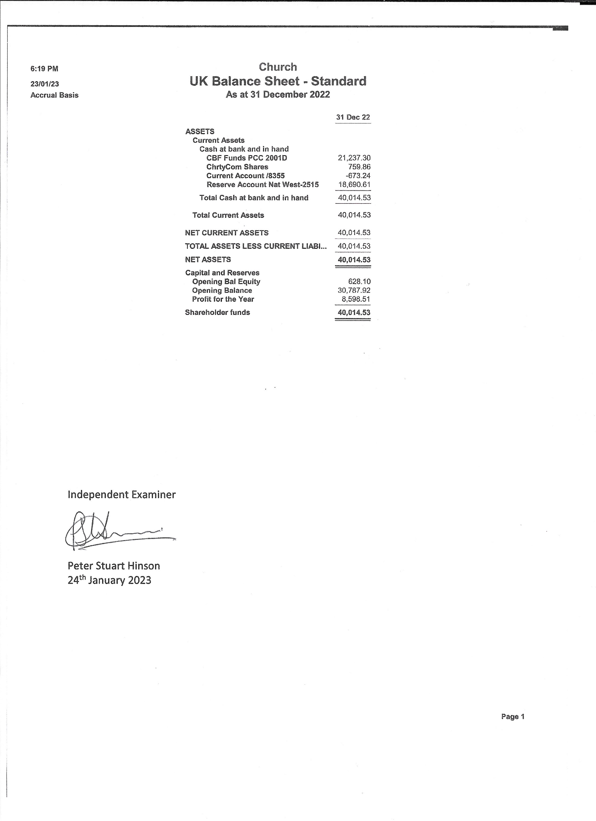

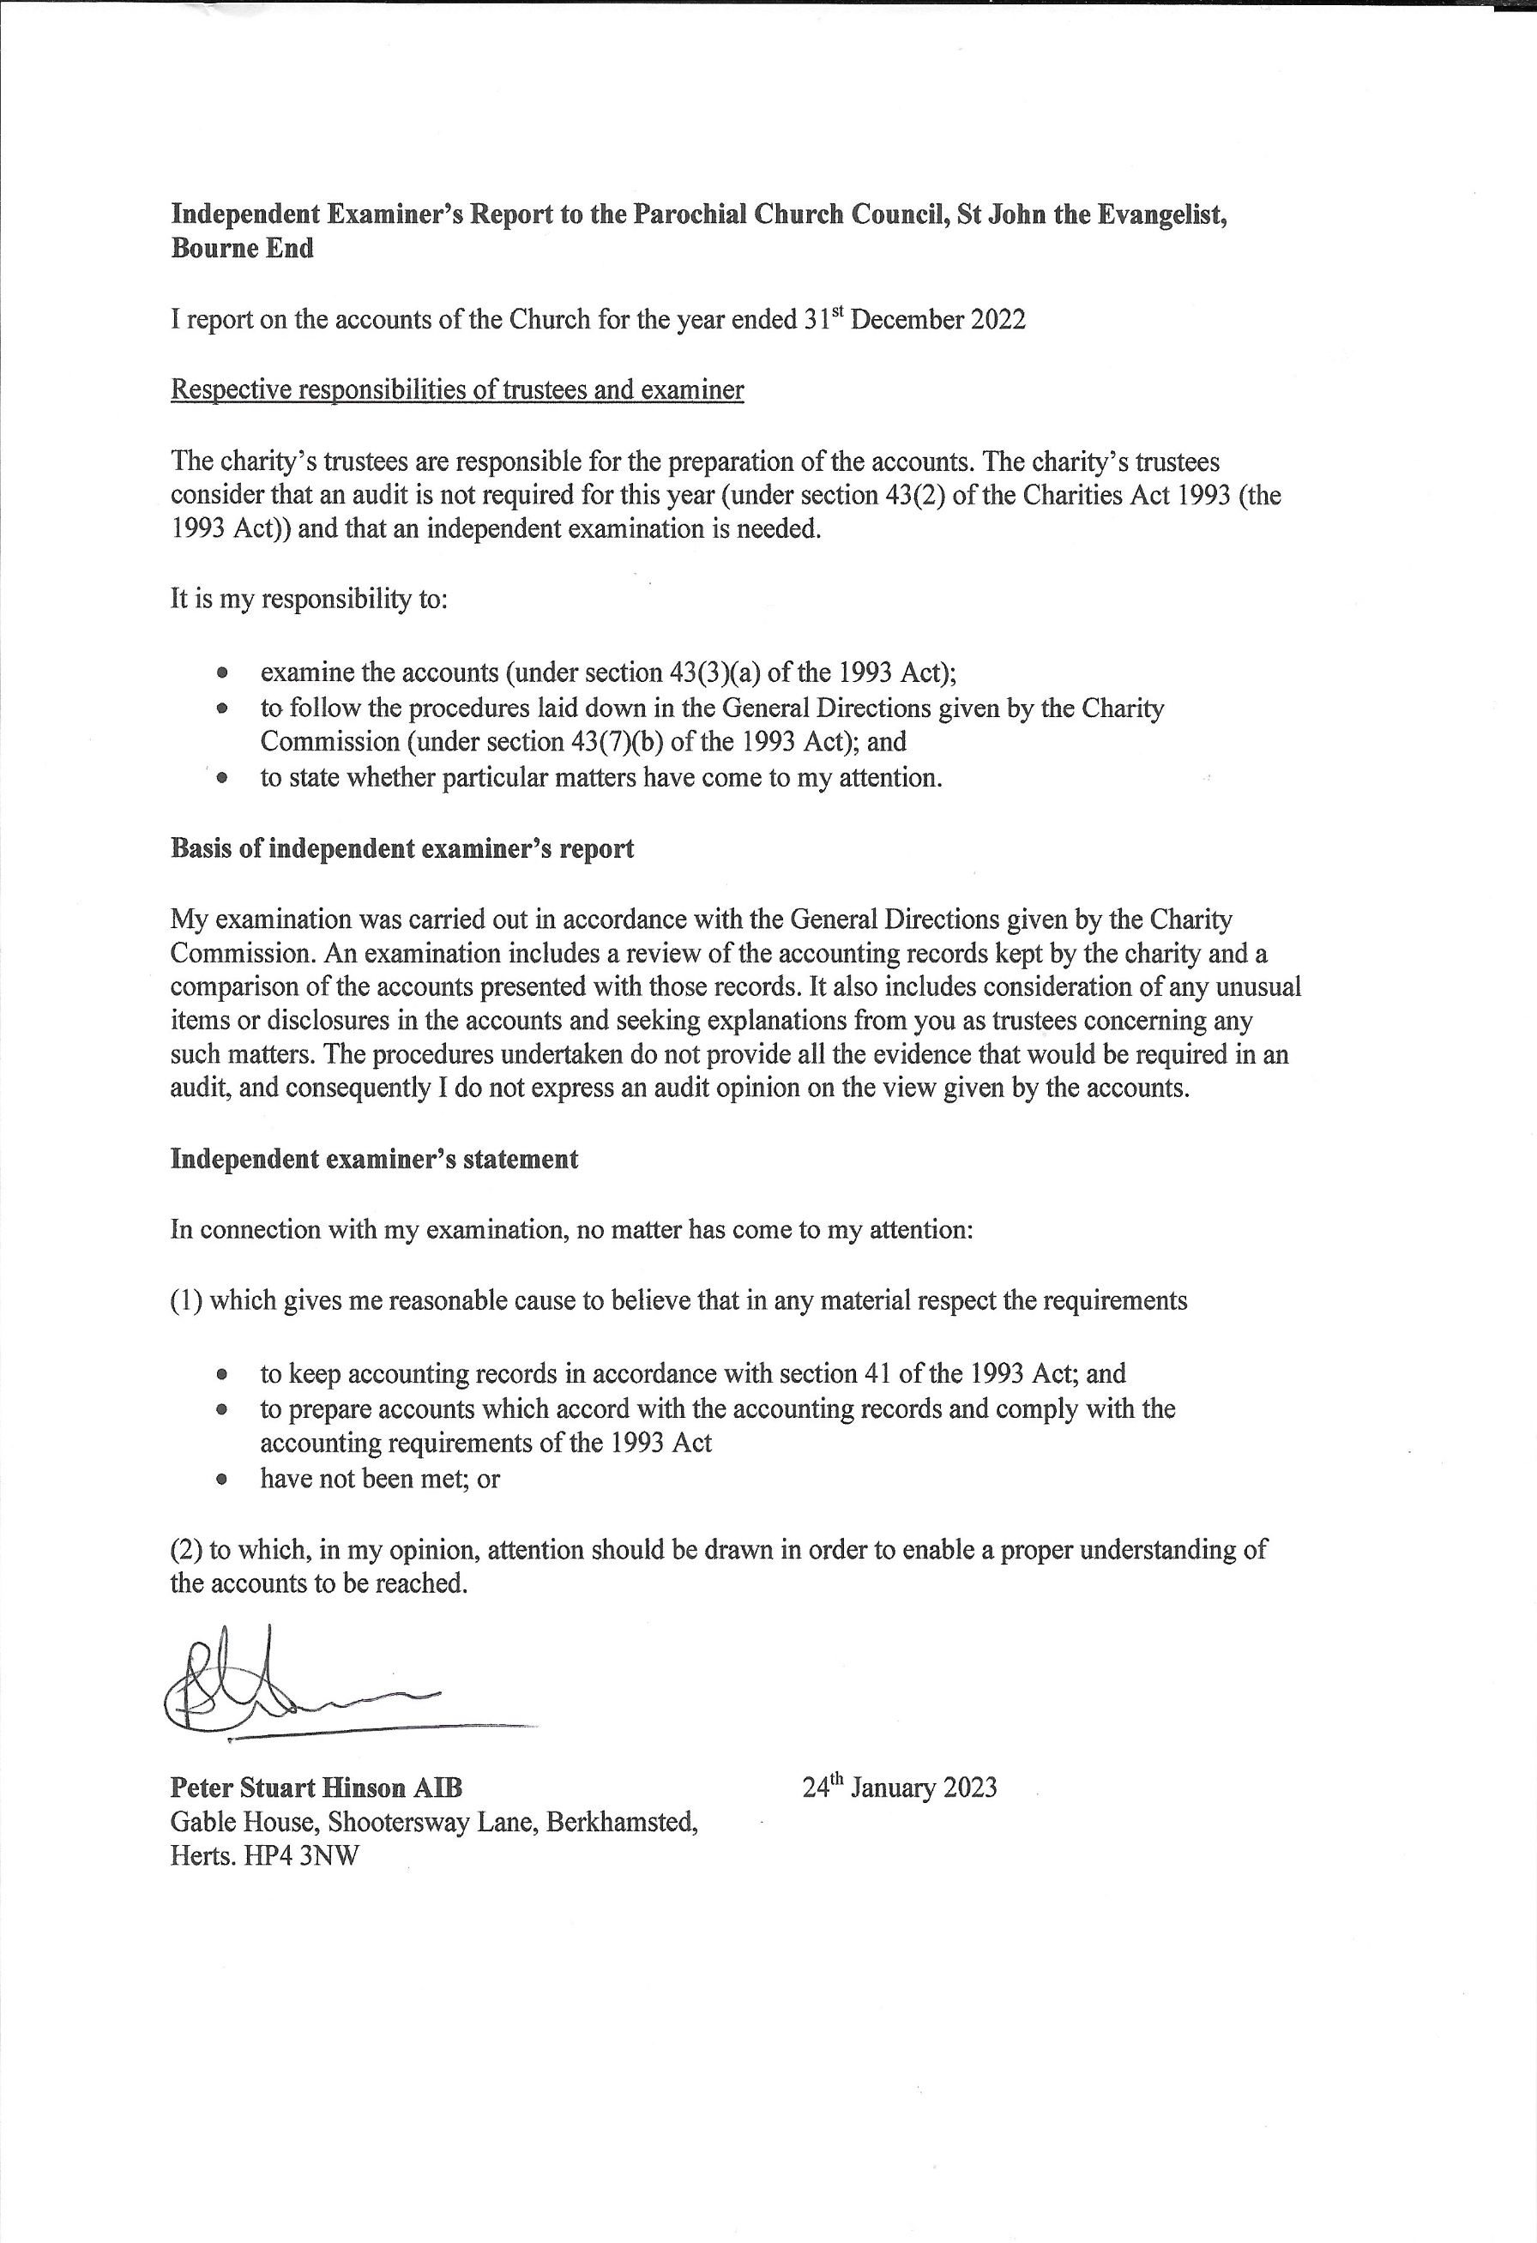
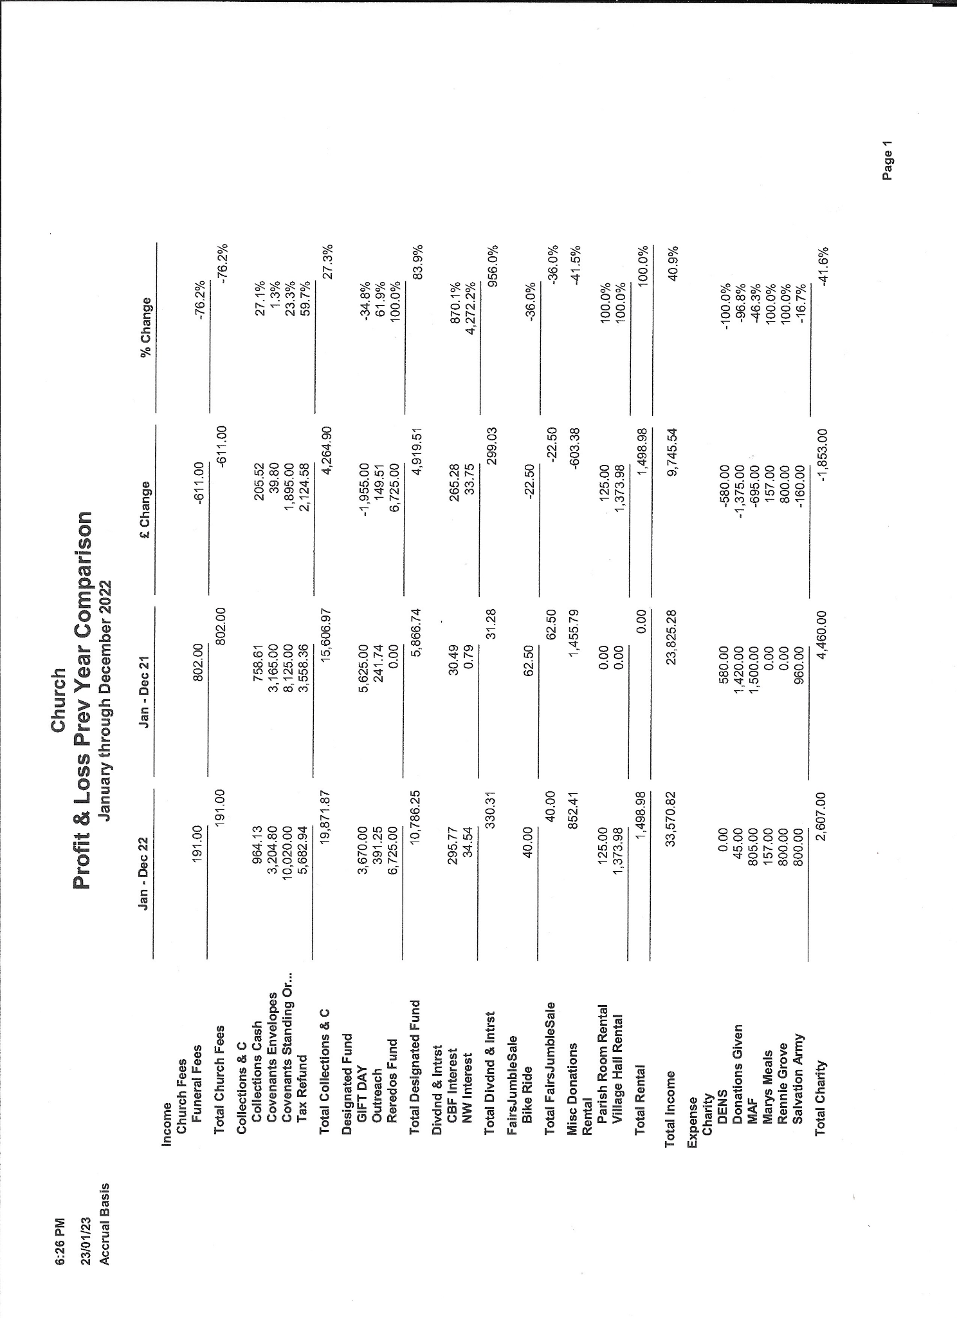
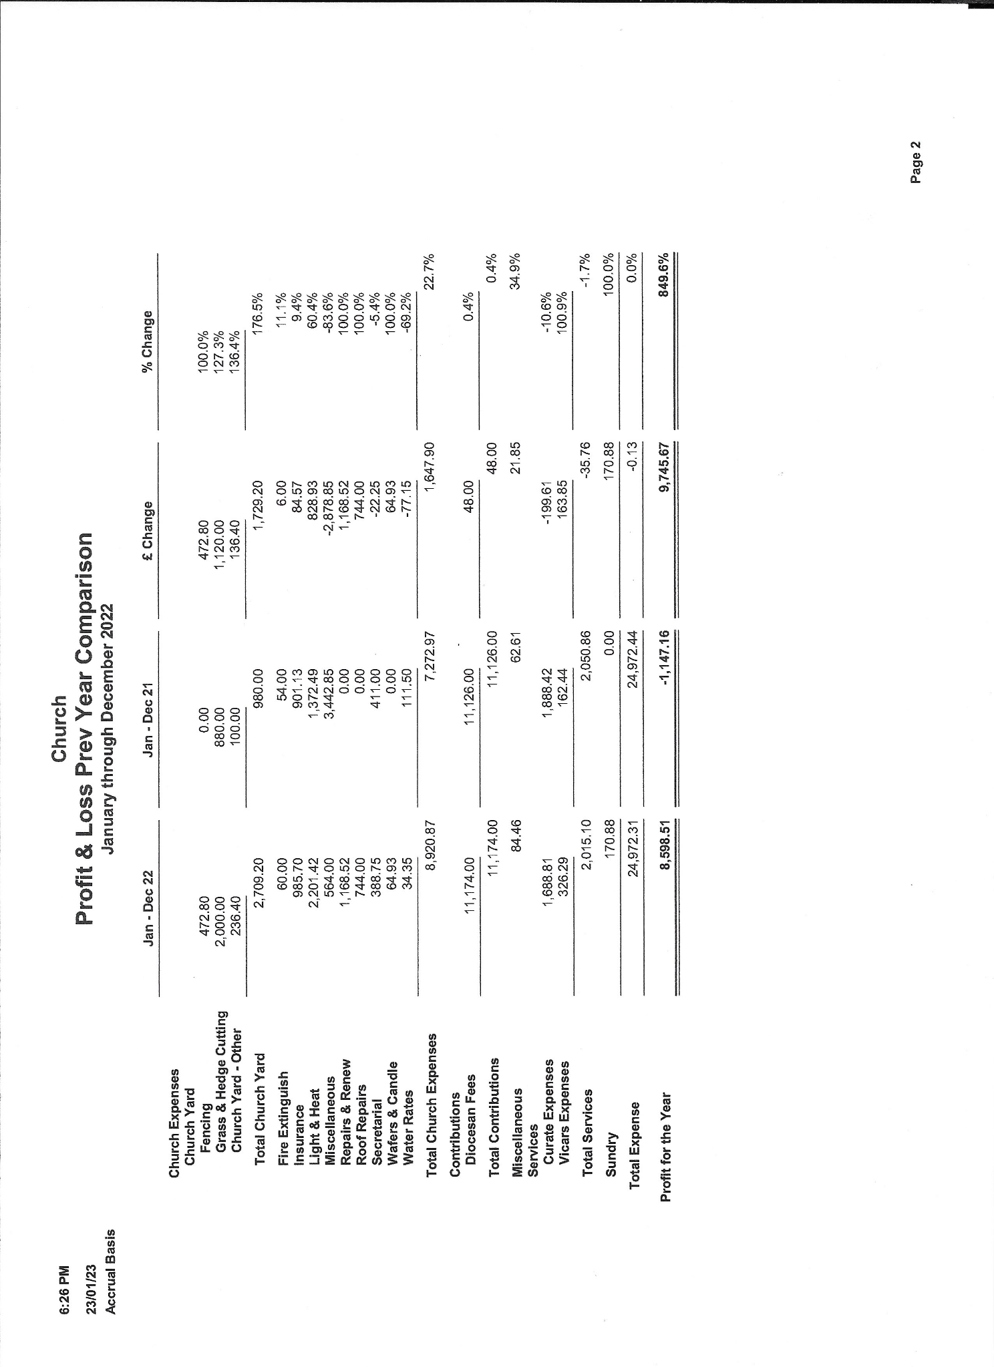
Electoral Roll Report 2022-2023
St. John the Evangelist, Bourne End Electoral Roll

Number | Surname | First Names
1 | Bailey | Rose
2 | Clark | Robert Norman E
3 | Clark | Susan Elizabeth
4 | Clarkson | Sheila Mary
5 | Connaughton | Kevin
6 | Driver | Barbara Mary
7 | Driver | John
8 | Evans | Karen Jayne
9 | Frey | Laura
10 | Good | Lesley Elizabeth
11 | Greenwood | Gladys May
12 | Gubbay | Audrey Alice
13 | Gubbay | David Robin
14 | Harkins | Edith
15 | Harkins | Robert
16 | Hoare | Robert
17 | Ivin | Janet Mary
18 | King | Helen Joan
19 | Manson | Catherine Jane
20 | Manson | David Charles
21 | Marshall | John
22 | Marshall | Susan Jean
23 | Pritchard | Michael Gwyn
24 | Rayner | Craig Douglas
25 | Scott | Stephanie
26 | Thomas | Alexander J S
27 | Thomas | Frances M
28 | Welch | Jenny

One member has died.
Three members have moved out of the area.
One member has moved to a different church.
There are three new members.

The Number on our Electoral Roll is 28.

